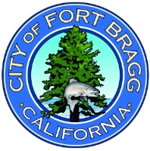
City of Fort Bragg
416 N. Franklin, Fort Bragg, CA 95437
Phone 707/961-2823 Fax 707/961-2802
COUNCIL COMMITTEE ITEM SUMMARY REPORT
MEETING Date: January 9, 2025
To: Public Works and Facilities
From: Chantell O’Neal; Assistant Director of Engineering
AGENDA ITEM TITLE: REVIEW SIGN QUOTES FOR NEW BAINBRIDGE PARK WELCOME SIGN AND MAKE RECOMMENDATION FOR SELECTION

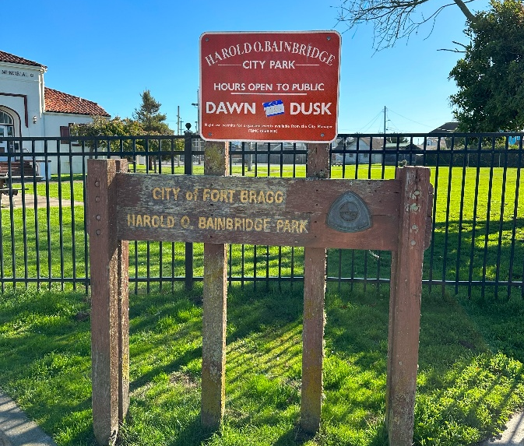
BACKGROUND AND OVERVIEW:
The City solicited quotes from qualified manufacturers, artists, and woodworkers to replace the Harold O. Bainbridge Park Welcome Sign. The existing sign is outdated and requires an upgrade as part of the overall Bainbridge Park Enhancement Project. The Request for Proposals (RFP) established criteria for a design that was both creative and artistic and captures the playful nature of a park for signage. Additionally, the RFP required:
- Sign Text should include the:
  - “Harold O. Bainbridge Park”
  - City of Fort Bragg name or logo (high-quality graphic available).
  - Park Hours: Dawn to Dusk with Spanish translation ““Horario del parque: del amanecer al anochecer”
- Any additional proposed text will require Spanish translation.
- Proposed Welcome Sign material may consist of Redwood Heart B, High-Density-Urethane (HDU), or other high-quality material that is coastal weather resistant.
- If the Welcome Sign is to be painted, the use of marine-grade paint is required.
- The new Welcome Sign shall be no larger than the existing sign configuration, i.e. no more than 6’ high, 8’ wide, and a maximum thickness of 9”.
- Both Post-mount and Monument style signs will be considered.
SCOPE OF WORK
Specific work tasks shall include:
1. Design a new sign, and receive final approval on the sign schematic.
2. Manufacture a new Welcome Sign.
3. Deliver the sign to the City of Fort Bragg if not proposing installation.
4. The proposer may also choose to install the sign, or this activity may be undertaken by City Public Works Staff. If the proposer installs the sign, they should bid that portion of the work as an alternate item. Persons electing to install signage must comply with prevailing wages, maintain necessary contractors' licensure, and provide sufficient insurance coverage endorsements.

The proposal content requested the inclusion of:
1. Sign design in color.
2. Sign dimensions.
3. Total cost of sign including post(s) or monument fixture.
4. Alternate cost for installation of the sign (if proposing). Please include as a separate line item, the cost to install the sign, including all posts, brackets, and hardware. All hardware must be 304 stainless steel. Proper licensure is required to bid on this alternate. (optional)
5. Project schedule – The Bainbridge Park Enhancement project is set to commence in early spring 2025. The sign shall be completed no later than March 1, 2025, unless an alternate agreement is reached with the selected sign contractor.

Proposal submittals were due November 15, 2024. The City received six (6) proposals which are summarized in a matrix form and depicted in the attachments. The Bainbridge Park Enhancement Project is funded by the State Parks Program grant for which the city received $2,063,100. The replacement sign is one element of the overall project with a current projected unit cost (including installation) of $16,800.00. Several of the signs submitted fall within this budget range and many others far exceed the available funding.

RECOMMENDATION:
Review the six (6) signs and make a recommendation for selection. If a more expensive sign is selected, funding options need to be explored to cover excess costs.

ATTACHMENTS:
- Sign Response Matrix
- Aloha Sign Proposal
- Paramount Sign Proposal
- Square Signs LLC Proposal
- Blink Signs Proposal
- Braggadoon Sign Proposal

