City of Fort Bragg, California

General Plan Maintenance Fees Report
Fiscal Year Ended June 30, 2024

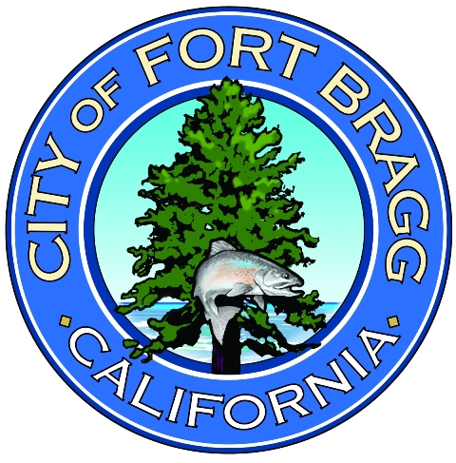

Prepared by City of Fort Bragg

For informational purposes the following information is presented in connection with the City’s General Plan Maintenance fund:

A brief description of the type of fee in the account or fund:

General Plan Maintenance Fee – The purpose of the General Plan Maintenance fee is to cover the costs reasonably necessary to prepare and revise the plans and policies that the City is required to adopt before it can make any necessary findings and determinations.

The amount of the fee:

FY 2023/24: General Plan Maintenance Fee: 0.53% of total Valuation.

AB 2936 was amended and is outlined in California Government Code Section 66014. The City Council instructed staff to thoroughly assess and document the foundation for a modified General Plan Maintenance Fee, ensuring it aligns with the reasonable cost estimates for the necessary preparation and revision of plans and policies required by a local agency. During this analysis, the City temporarily suspended the collection of the General Plan Maintenance Fee through Resolutions 4314-2020, with extensions through Resolutions 4398-2021 and 4471-2021. In January 2023, the City Council approved a reduction in the General Plan maintenance fee from 1.5% to 0.53%.

Statement of Revenues, Expenditures, and Changes in Fund Balance

The Fees were expended to pay consultant time spent developing, reviewing, and revising the Inland General Plan, the Local Coastal Program Amendment, updates to the Inland Land Use and Development Code (Title 18 of the Municipal Code), and other related ordinances of the Municipal Code.

A detailed list of staff time and vendor transactions is attached to this report as attachment A.

For the fiscal year 2024, updates to the City’s General Plans and other City plans and policies included the following:

- The City of Fort Bragg hired a consultant, Marie Jones Consulting (MJC), to complete MJC also worked on the Fire Sprinkler Ordinance, the Building Code Update Ordinance, the Business License Tax Fee, and Initiatives to bring affordable housing to Fort Bragg. She provided assistance with amendments to the City’s Mobile Vending Vehicle policy and worked on Housing Element implementation to update the Vacant Parcels Workbook.

- MJC prepared the Local Coastal Plan Amendment for submission to the California Coastal Commission to update the Local Coastal Program with the new Inland downtown parking ordinance for the elimination of parking minimums in the Central Business District.

- MJC to complete Inland zoning code amendments adding the following new ordinances to the ILUDC: Urban Lot Split Ordinance, and Urban Unit Development Ordinance. These ordinances will also be adopted into the Local Coastal Program as part of an LCP update.

- Additionally, Marie Jones Consulting prepared amendments to the Tiny Homes Ordinance, the Planned Unit Development Ordinance, and the Accessory Dwelling Unit Ordinance of the ILUDC. These ordinances will also be adopted into the Local Coastal Program as part of an LCP update.

- MJC completed a new Tiny Home Communities Ordinance and an Outdoor Dining Ordinance for inclusion into the ILUDC and the LCP.

- Her work also included the preparation of an MND for Outdoor Dining, Tiny Home Communities & Planned Unit Development ordinances.

- Finally, MJC completed an LCP amendment to rezone 113 acres of the former Mill Site to a mix of Parks and Recreation, Medium Density Residential, and Public Facilities zoning. This rezone was for property owned by the City, Noyo Center, and Sherwood Valley Band of Pomo.

